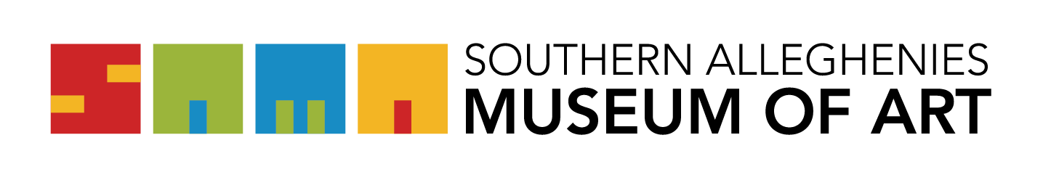
Artists of the 21st Century: Student Art Exhibition 2022

Letter of Intent/Acknowledgement Form

Please print, legibly.

I, ____________________________________________________, am submitting this letter of intent to participate in the Artists of the 21st Century: Student Art Exhibition.

SCHOOL____________________________________________________________
SCHOOL DISTRICT:___________________________________________________

I acknowledge that I have read and agree to abide by the guidelines as they pertain to the Student Art Exhibition and SAMA regulations. I understand if the guidelines are not met for any object, that object will be excluded from the exhibition.

Check the Museum your school will be exhibiting at:
____ SAMA Ligonier ____ SAMA Loretto

Authorized signature:_________________________________________________ Date:____________________________________________________________

Agreement of Responsibility

The Southern Alleghenies Museum of Art (SAMA) will take the appropriate measures to ensure the safety of the artwork during installation and while on display. Any loss OR damage to the artwork is NOT the financial responsibility of the Museum.

I verify that I have ready and understand the above statement:

_________________________________________________ Date:________________
This form is to be mailed to SAMA Loretto, Post Office Box 9, Loretto, PA 15940 or emailed to loretto@sama-art.org.

ALL LETTERS MUST BE RECEIVED BY FRIDAY, NOVEMBER 19, 2021

